2024

Vitali Turkin

N11889799

5/10/2024

CAB230 Assignment 2 Client Side



CAB230

Volcano API – Client-side Application

Contents

Introduction 2

Purpose & description 2

Completeness and Limitations 3

Use of End Points 4

/countries 4

/volcanoes 5

/volcano/{id} 6

/user/register 8

/user/login 9

Modules Used 10

React 10

Ag-grid-react 10

Chart.js 10

React-chartjs2 10

Pingeeon-maps 10

React-router-dom 10

Module 3 10

Application Design 10

Navigation and Layout 10

Usability and Quality of Design 10

Accessibility 11

Technical Description 12

Architecture 12

Test plan 14

Difficulties / Exclusions / unresolved & persistent errors 14

Extensions 14

User guide 15

References 18

Appendix 19

## Introduction

### Purpose & description

Through an API in a React-based application dedicated to volcanoes, users can get full information on individual volcanoes or lists of volcanoes inside particular countries worldwide. In the same way, they can sign up or log in to obtain even more data about the inhabitants of the volcanoes.

This project satisfies all of the functional requirements specified in the assignment and has a contemporary, user-centric design with dynamic button animations. For instance, when the cursor is over the homepage buttons, the text colour and border change, and the navigation bar buttons also have hover effects—lines. Additionally, recommended modules like pigeon-maps are included in the application to enhance its functionality, ag-grid for table-formatted volcano data presentation, respectively and chart.js-2 for visualising population density as a bar chart. Photographs, colour schemes, and CSS properties are meticulously arranged to create the application's visual style.

Modules utilised:

* react-chartjs-2: Uses dynamic bar charts to show population density data.
* ag-grid: Enables the construction of dynamic and feature-rich volcano data tables.
* Pigeon-maps.js: Adds geographical mapping features to the application.
* Pure CSS: Offers a lightweight and basic way to styling web components without relying on major CSS frameworks such as Bootstrap or Foundation.

The provided screenshots emphasise key design decisions and show how these aspects promote an intuitive user experience:

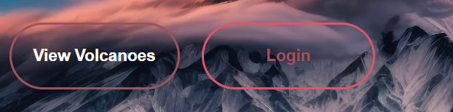

Figure 01: Hover of one of the buttons on landing page



Figure 02: Hover of navigation in header part

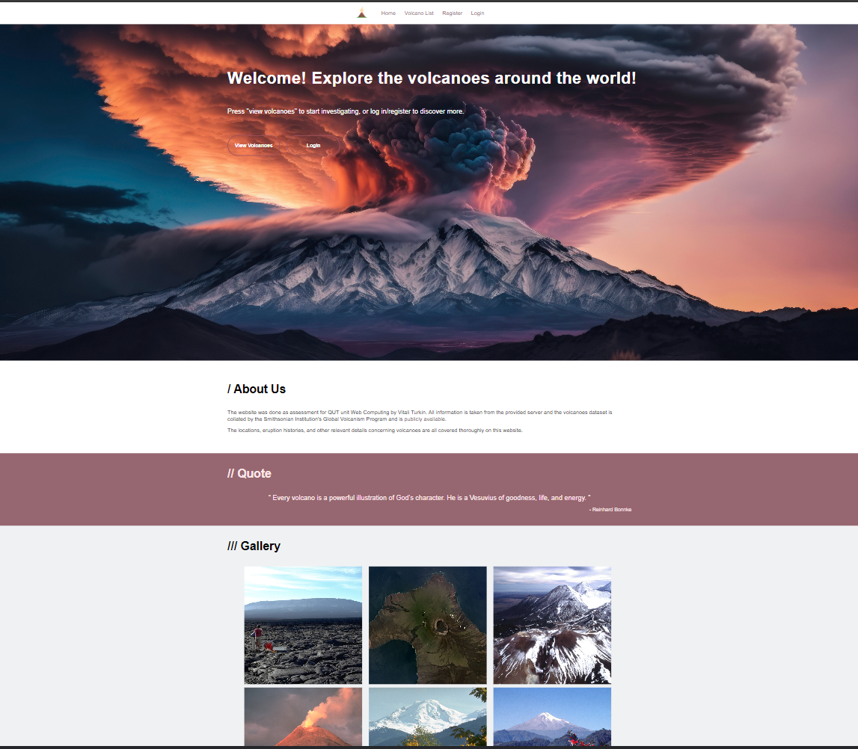

Figure 03: Landing Page

### Completeness and Limitations

React Router is used in the current application to make page navigation simple for users, making the experience more user-friendly. Users may effectively filter and sort data within the table with the help of the Ag-Grid components, which also make it easier to integrate the search form. This improves data interaction and usability. The website's design places a strong emphasis on alignment and cleanliness to make sure that every element efficiently communicates the pertinent information it represents. Two additional components that add significant visual meaning to the presented data are a bar chart that shows population density and a map component that shows the locations of volcanoes.

The Login/Register/Logout system provides a consistent user experience through logical page transitions. Strong error handling is in place throughout registration and login, providing users with immediate feedback when difficulties arise.   
  
Important components of the programme include regulated form inputs, rapid navigation, and strong component and data alignment. The user experience is enhanced with the addition of map and chart components, which offer visual insights into the spatial and demographic features of the dataset.

However, to attain a higher grade level, additional refinement may be required in specific areas, such as optimising data querying to reduce server requests and improving design components for enhanced usability.

## Use of End Points

#### /countries

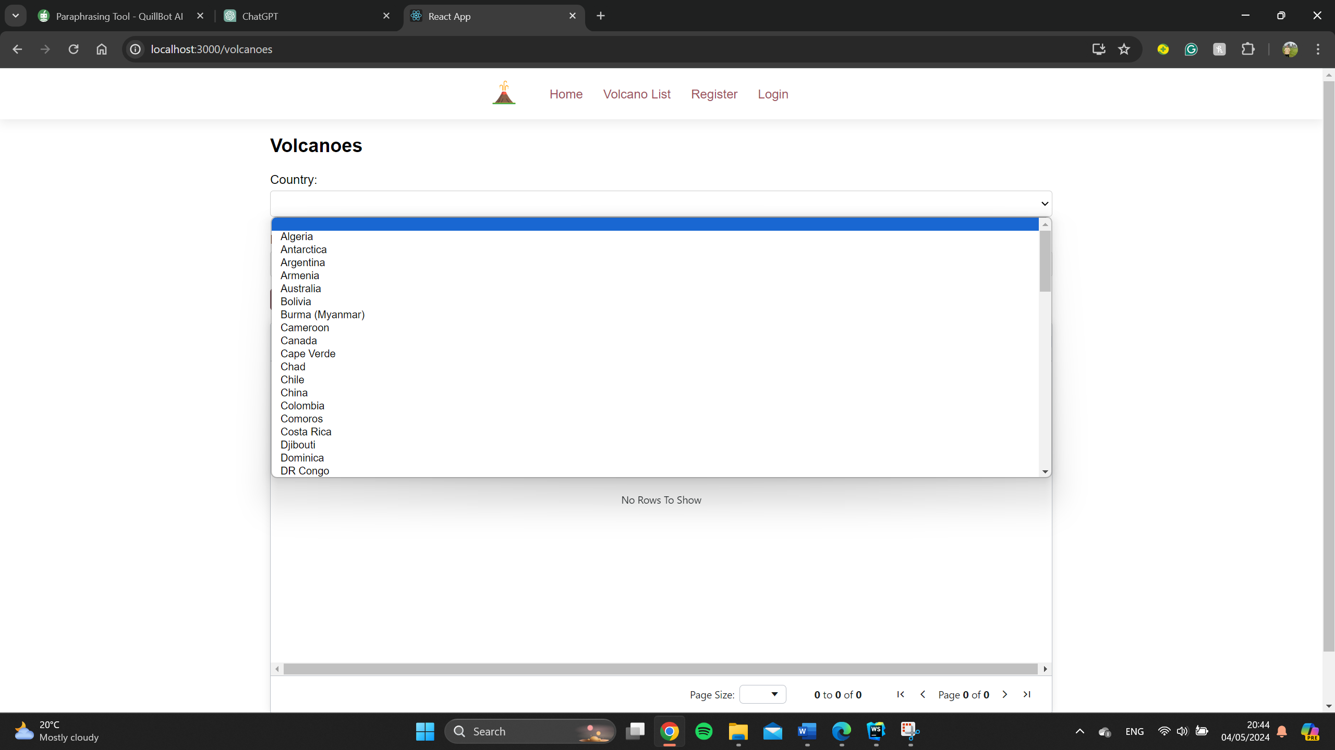

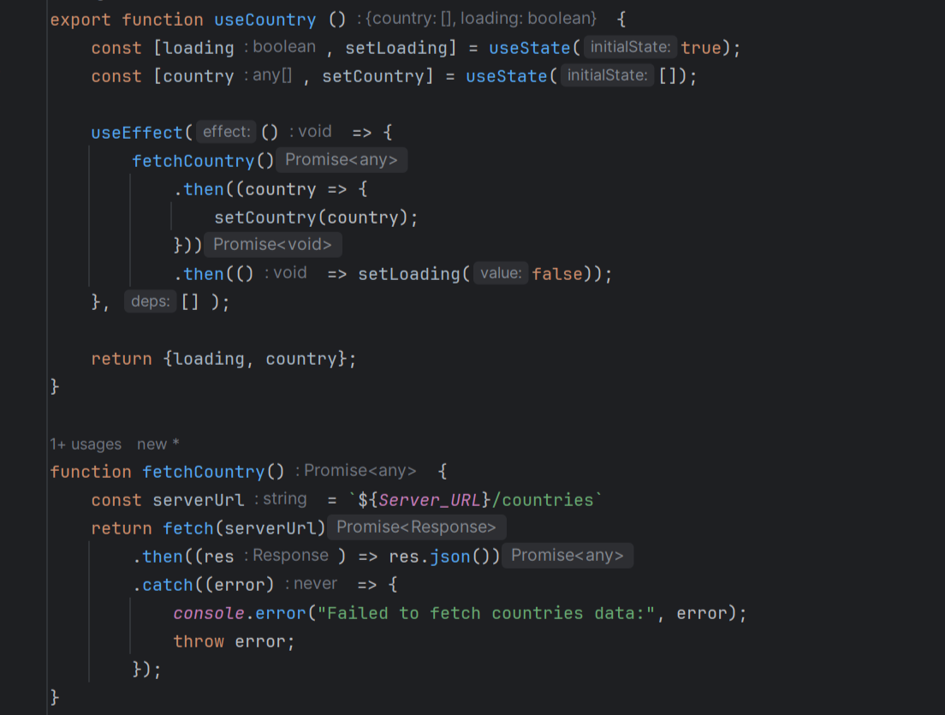

Figure 04 and 05: When user click to the country selector the name appears (code provided)

#### /volcanoes

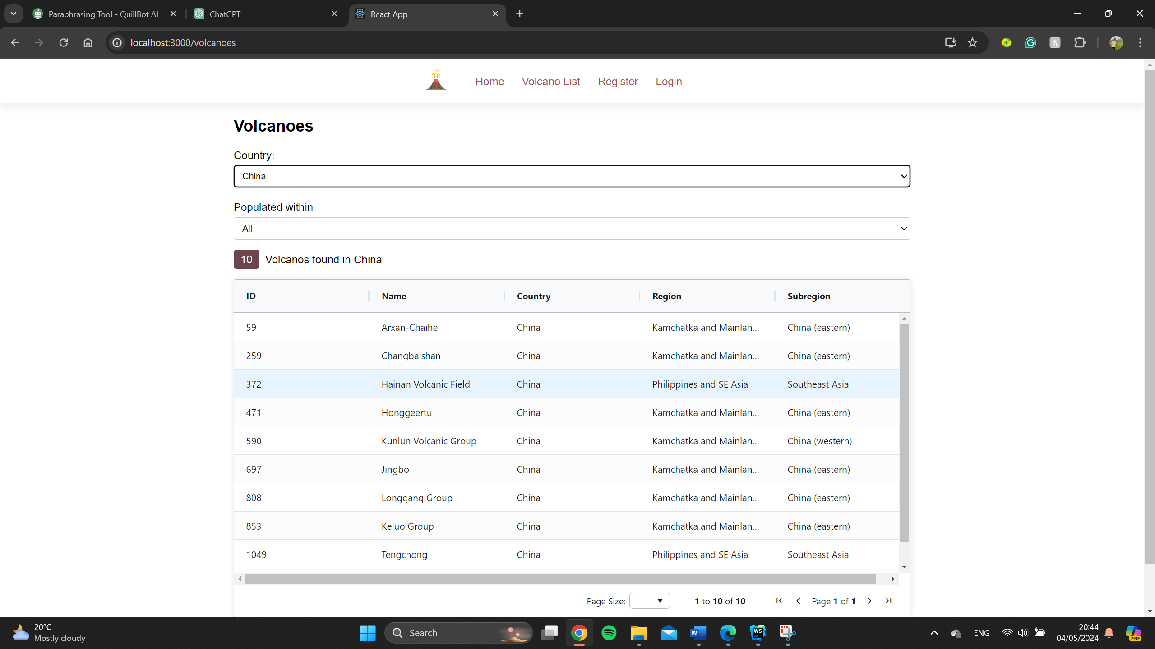

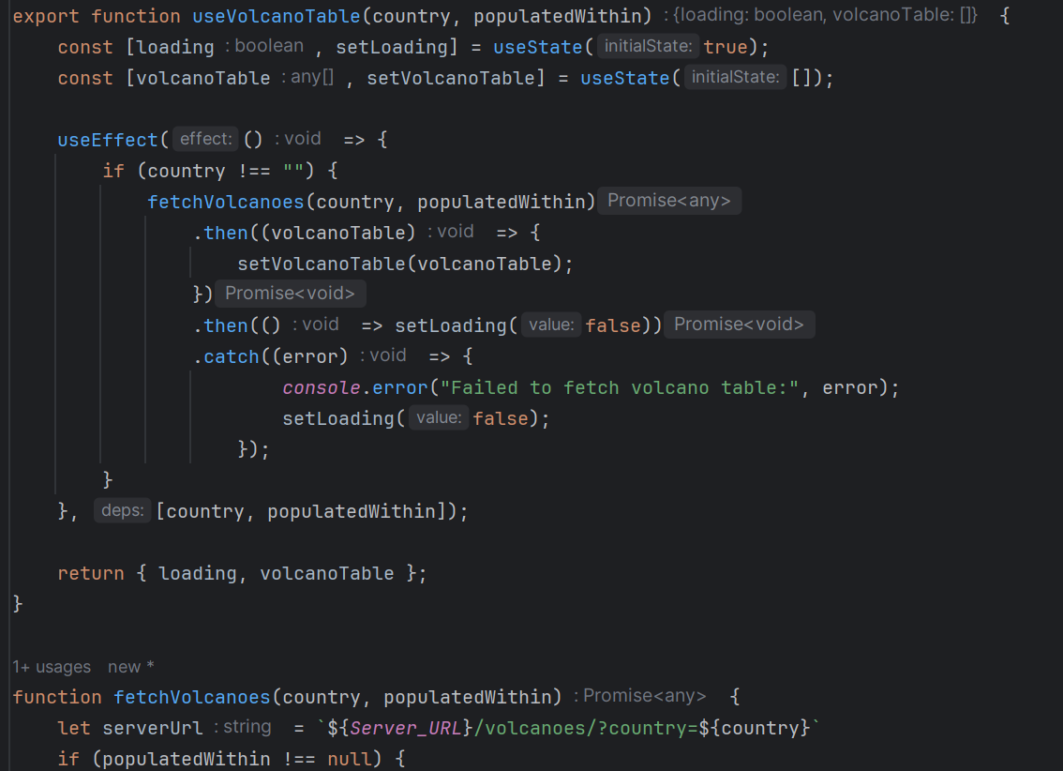

Figure 06 and 07: After selecting the country the full table appears with different volcanoes and number (code provided)

#### /volcano/{id}

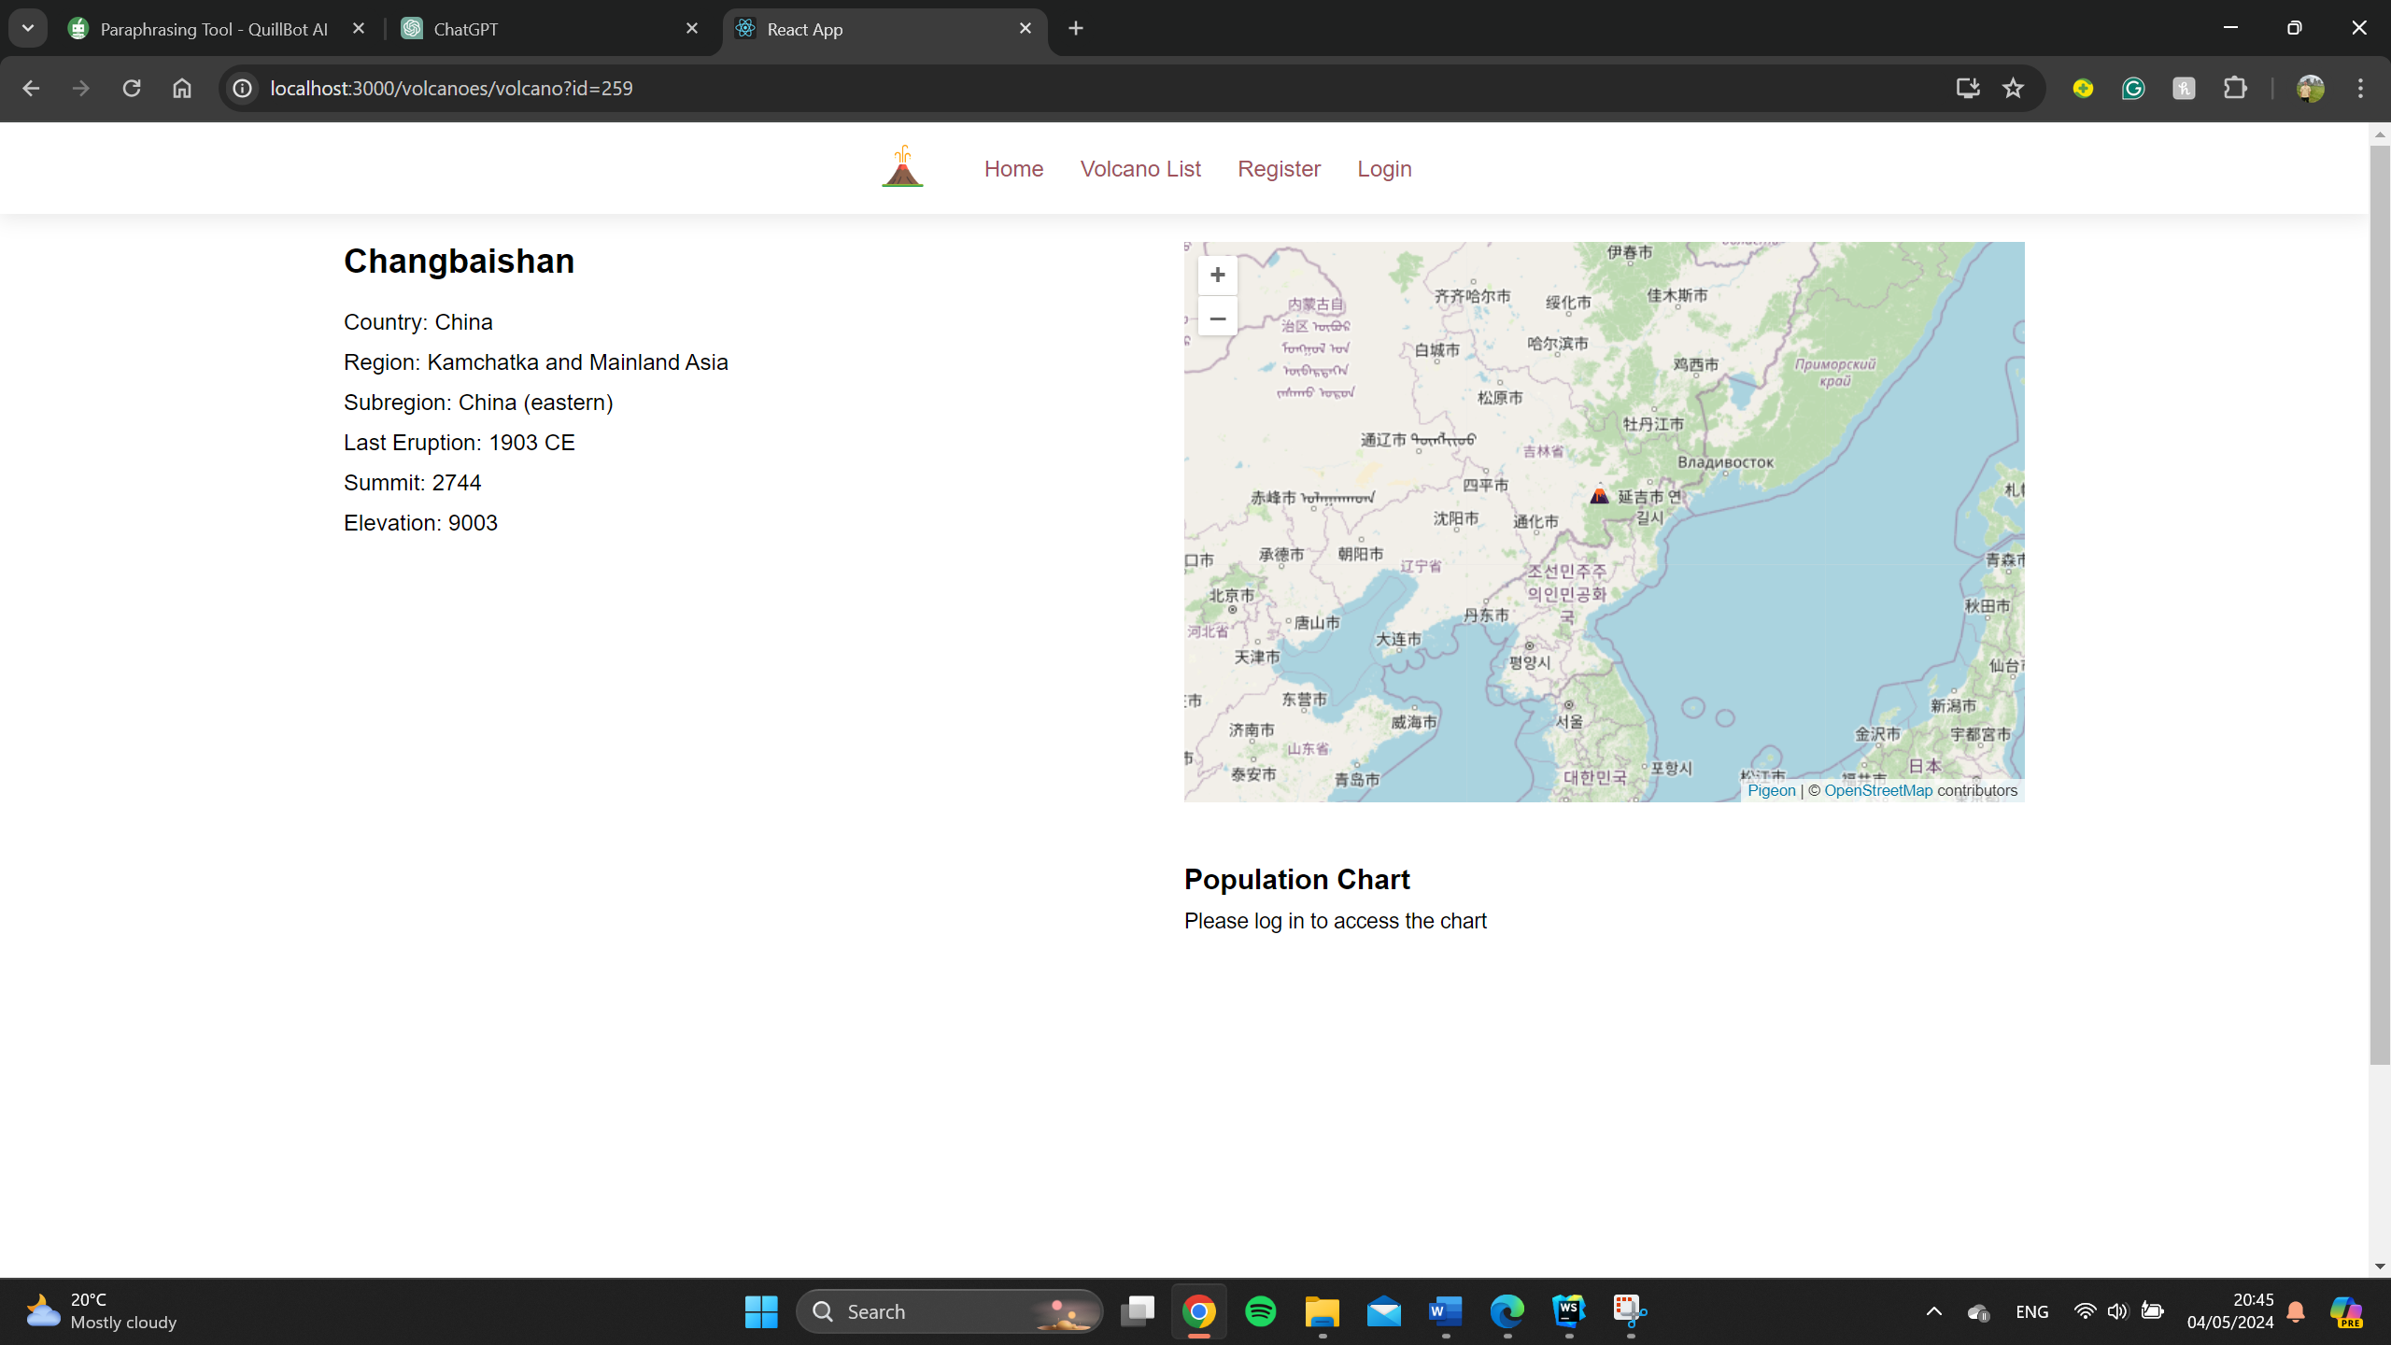

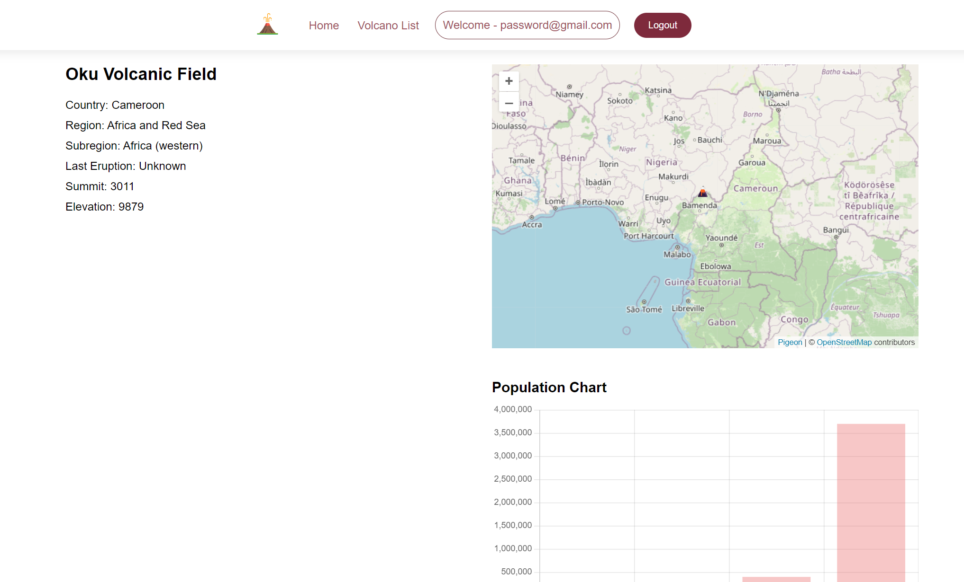

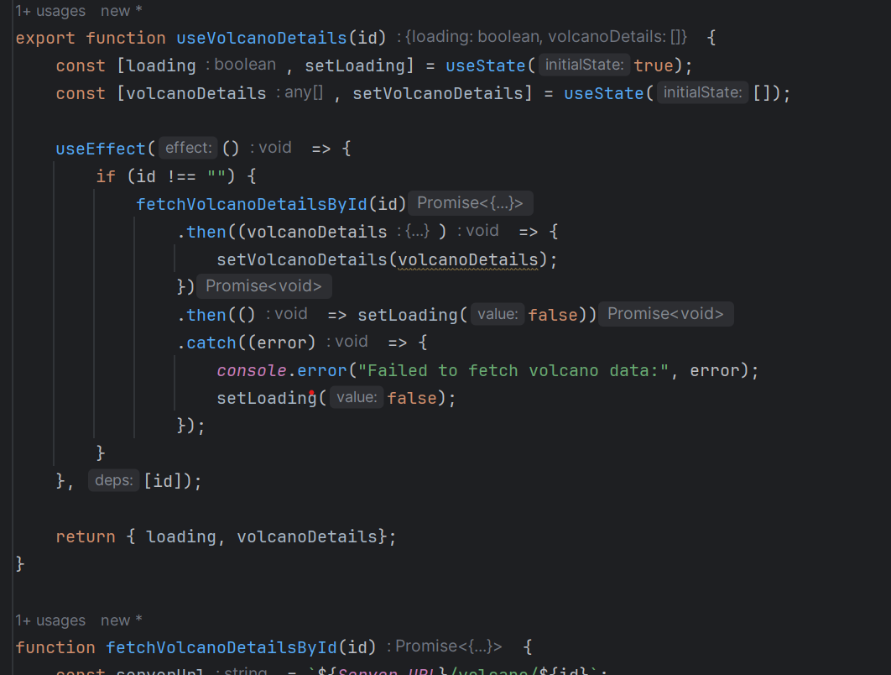

Figure 08,09 and 10: When user select the volcano from the table, the app directs user to details showing information and location. If user is logged in then population chart appears (code provided)

#### /user/register

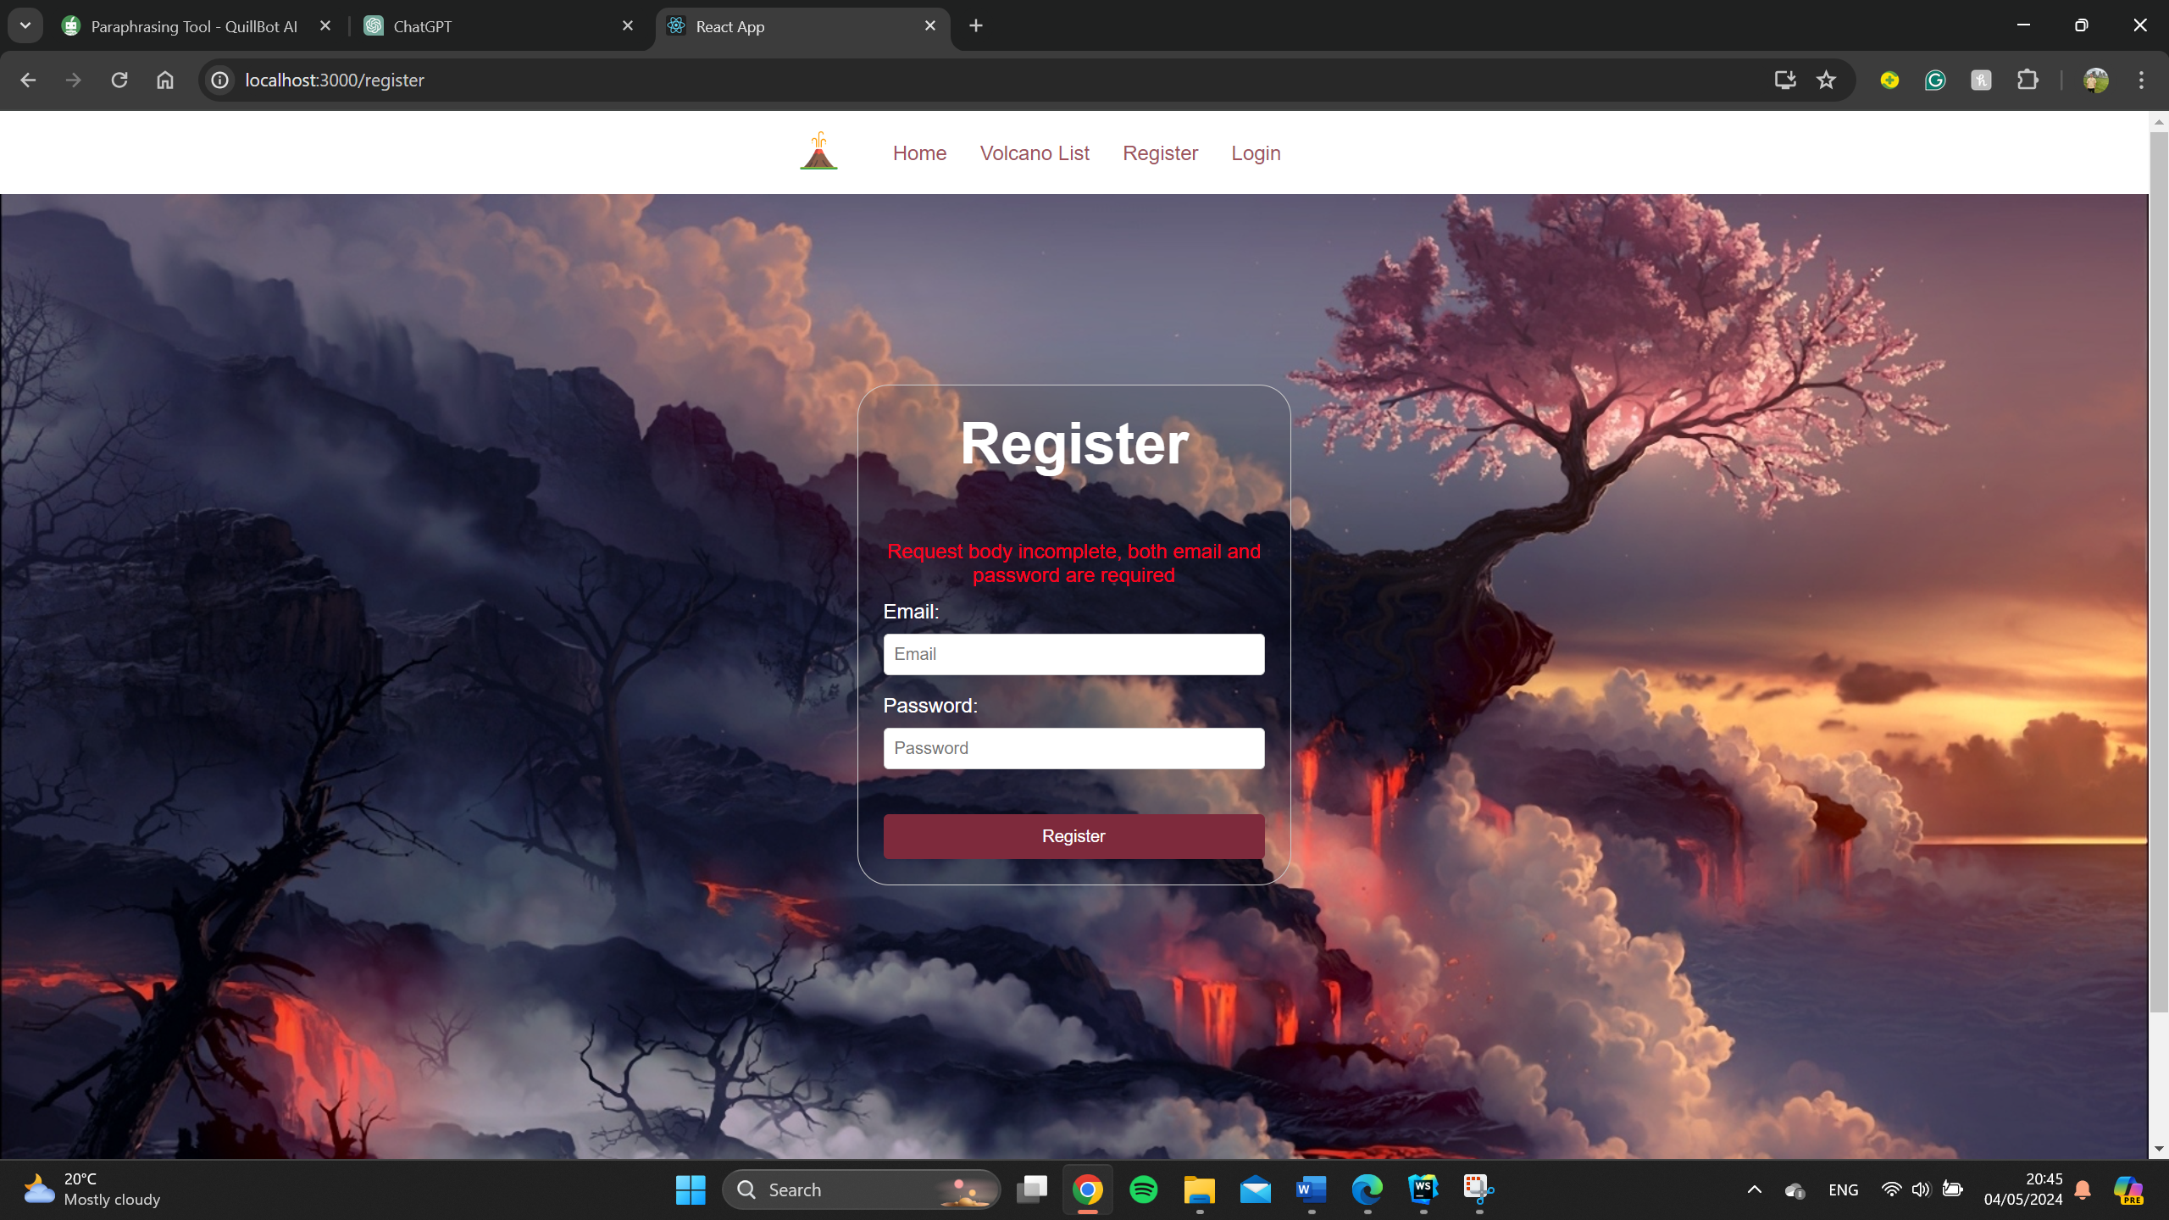

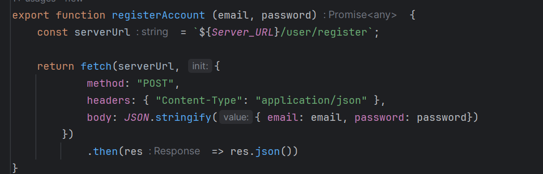

Figure 11 and 12: In order to see the population chart user has to register. If something is going wrong like invalid email and other error the message will appear to inform user. And after successful registration user is taken to login page (code provided)

#### /user/login

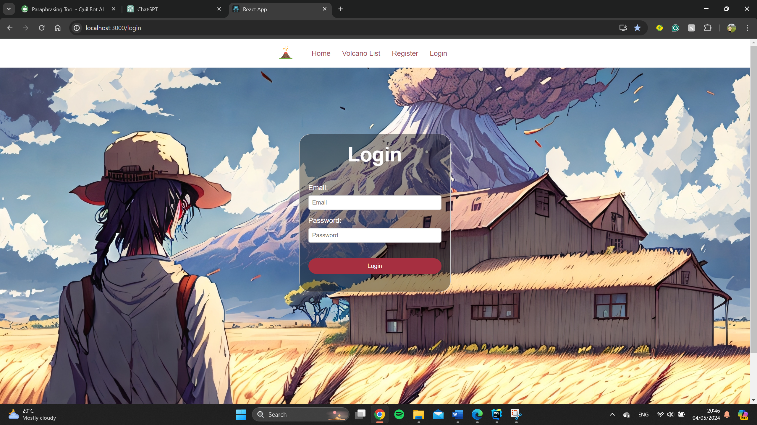

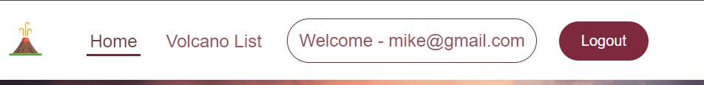

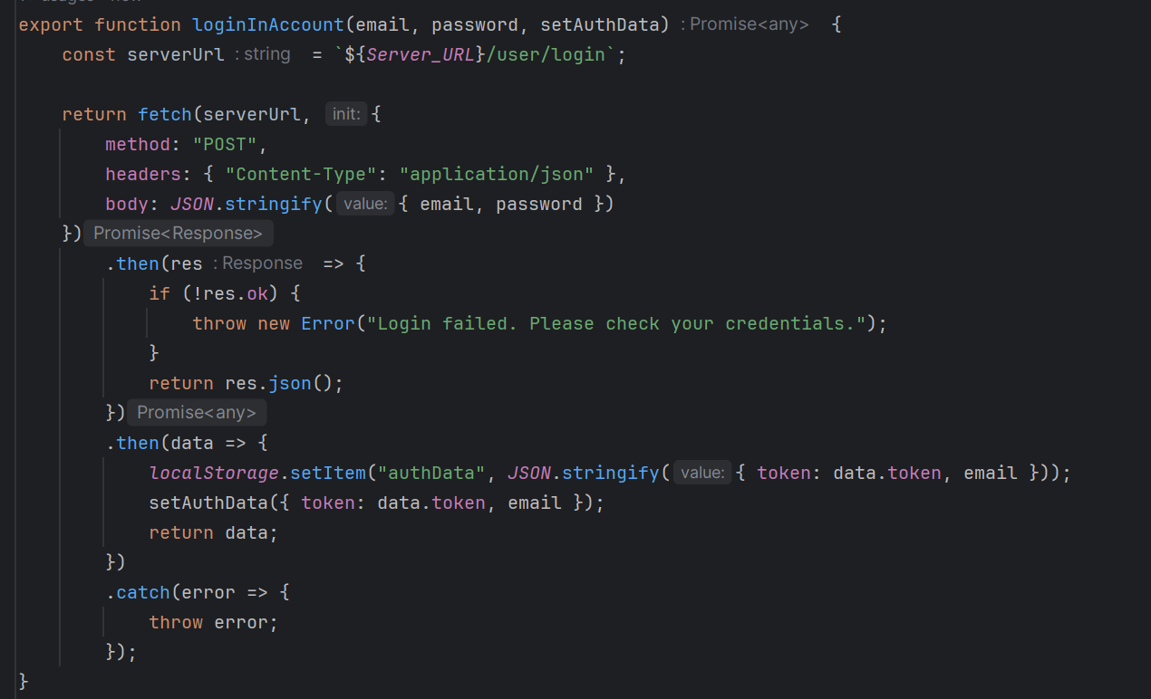

Figure 12,13 and 14: After registration the user has to login. If there is an error the message will appear as in registration form. After successful logging the user is taken to home page and the navigation bar updates not to show register and login page but welcome username message appears with logout button (code provided)

## Modules Used

#### React

React is a JavaScript library that creates user interfaces. It enables developers to construct reusable UI components that refresh efficiently as data changes.

<https://react.dev/>

#### Ag-grid-react

Ag-Grid is a robust framework for creating data grids and tables in React apps. It offers a variety of capabilities such as sorting, filtering, grouping, and more.

<https://www.ag-grid.com/react-grid/>

#### Chart.js

Chart.js is a popular JavaScript tool that allows you to create flexible and customisable charts and graphs on your website. It supports a variety of chart types (bar, line, pie, etc.).

<https://www.chartjs.org/>

#### React-chartjs2

React-chartjs2 is a React wrapper for Chart.js that makes it easier to utilise Chart.js within React components.

<https://www.npmjs.com/package/react-chartjs-2>

#### Pingeeon-maps

Pingeeon Maps delivers a performance-first, React-centric expandable map engine.

<https://pigeon-maps.js.org/>

#### React-router-dom

React-router-dom is a package that adds routing features to React applications.

<https://www.npmjs.com/package/react-router-dom>

#### Module 3

## Application Design

### Navigation and Layout

The header of each page will include a navigation bar, allowing users to explore the map. The navigation bar buttons will lead to responsive pages on the site. If a user successfully registers, they will be directly directed to the login page. If they provide incorrect information, they will receive an error notice in the register/login form. Additionally, in successful login circumstances, the login site's navigation bar will include an extra logout button and hide registration and login choices.

### Usability and Quality of Design

The online application's design might be defined as clean, modern, and minimalist, with an emphasis on simplicity, particularly in tables and charts. The overall style gives users a professional look, with logically organised widget UIs that are clean and intuitive. However, there is room for improvement, particularly in colour customisation and typeface uniformity.

The colour palette is appropriate and consistent, adding to the finished impression. However, several features of the design, such as the colour of data visualisation elements like the columns of the population bar chart and their simplicity.

Incorporating a more professional design style with improved colour scheme and contrast may benefit the design in the future. This method would result in a visually appealing and user-friendly interface that remains clear and readable throughout the application.

The navigation has been done in a straightforward and easy-to-understand design. However, there is a lack of user notifications during page transitions (e.g., from login to home or register to login site). Users can still understand the web environment and receive relevant information by clicking on specific buttons on the navigation bar. To address this issue, consider using contemporary CSS frameworks and their components.

### Accessibility

According to the W3S checklist:

* The website provides text equivalent such as alt for every non-text elements such as images. (achieved)
* It ensures that all information conveyed with color is also available without color, for example from context or markup. (Mostly)
* Website organises documents so they may be read without style sheets. For example, when an HTML document is rendered without associated style sheets, it must still be possible to read the document (achieved).
* It ensure that text equivalents are updated when dynamic content changes (achieved).
* Avoid causing the screen to flicker(achieved).
* Use the clearest and simplest language appropriate for a site's content(achieved).
* For tables, identify row and column headers – clearly differentiated from the data(achieved).

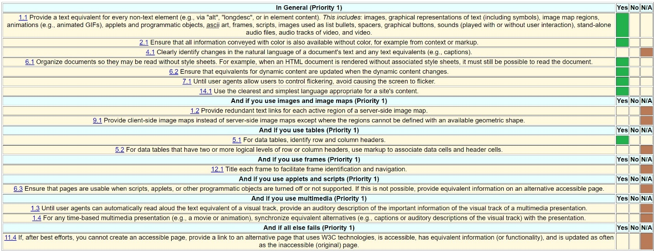

## Technical Description

### Architecture

Overview of the programme folder:

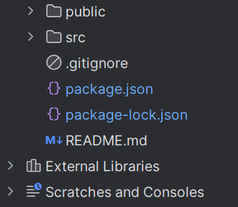

The public folder contains the images and fonts used for the programme.

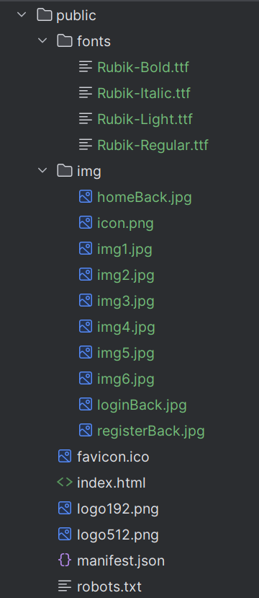

Source code folder:

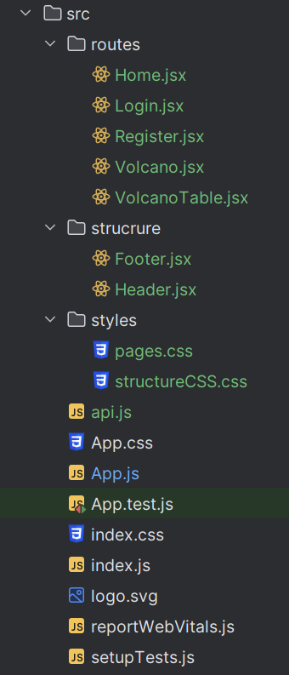

I have created 3 main folders routes, structure and styles –

Routes – stores all pages for the website

Structure - stores main components – header and footer

Styles – stores CSS code for styling

Also:

App.js for ensuring the routing source code appears clean.

api.js – stores url for backend server and main functions

The rest are created automatically for React

### Test plan

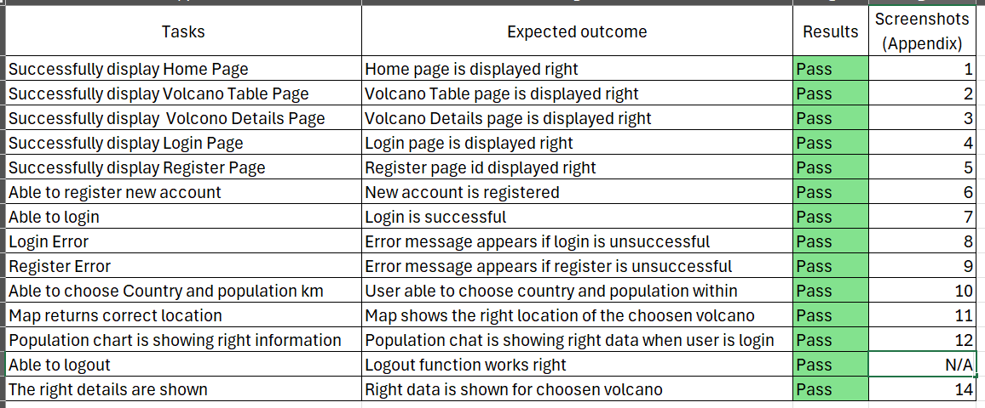

Difficulties / Exclusions / unresolved & persistent errors /

One of the major issues was integrating token-based authentication and dynamically presenting charts on volcano page based on user authentication. I addressed this issue by using **localStorage** for token management.   


Could use “Switch” for navigation, but found solution in “useNavigation”



Another hurdle was design; while I'm pleased with the current arrangement, there are potential for improvement.

## Extensions

Some possible add-ons or upgrades for app include the following:

* A more contemporary notification system,
* Additional ways to inform users when something changes within the app,
* A function for forgetting passwords during login,
* Accessibilities,
* User profile,
* Email verification.

## User guide

1. Download the application.

2. Install all required components

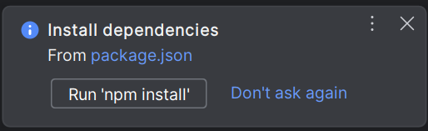

3. Open Visual Studio Code (I used WebStorm) and locate the path you stored the application then run it in the terminal – npm start



4. You now can see the landing home page in <http://localhost:3000/>



5. You can go to another page by using navigation bar on top or using two buttons





6. After pressing “View Volcano” button or “Volcano List” can view volcanoes in table depending on the country you choose



7. To login you need to be registered first - just go straight to Register on both Home page or navigation.



8. If successfully register an account, the page will automatically refresh then show login site



9. When successfully login the web will refresh and lead to Home page. To see full details of a volcano just go back to View List, choose country and volcano

11. When you done with browsing the volcano page just simply click on Back button and it will lead back to the Volcano table page



12. When you have finished and want to logout, simply click on button on top in the navigation.



## References

* MIT, INRIA, Keio W3C. Checklist of Checkpoints for Web Content Accessibility Guidelines 1.0, 1999, from <https://www.w3.org/TR/WAI-WEBCONTENT/full-checklist>

# Appendix



Screenshot1

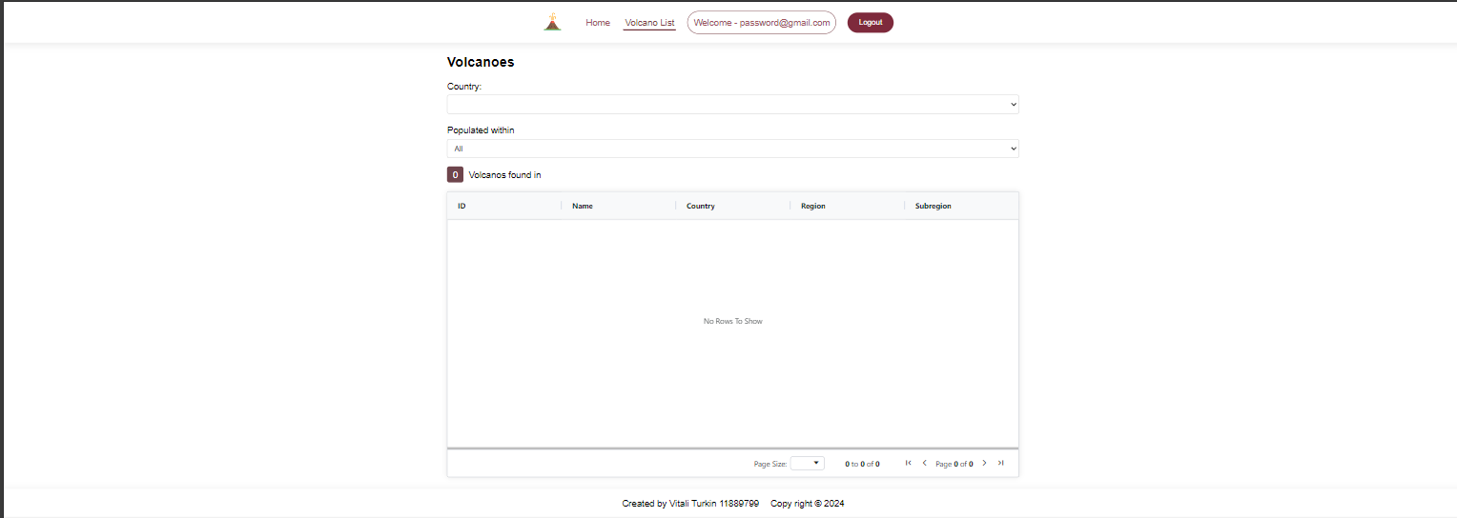

Screenshot2



Screenshot3



Screenshot4

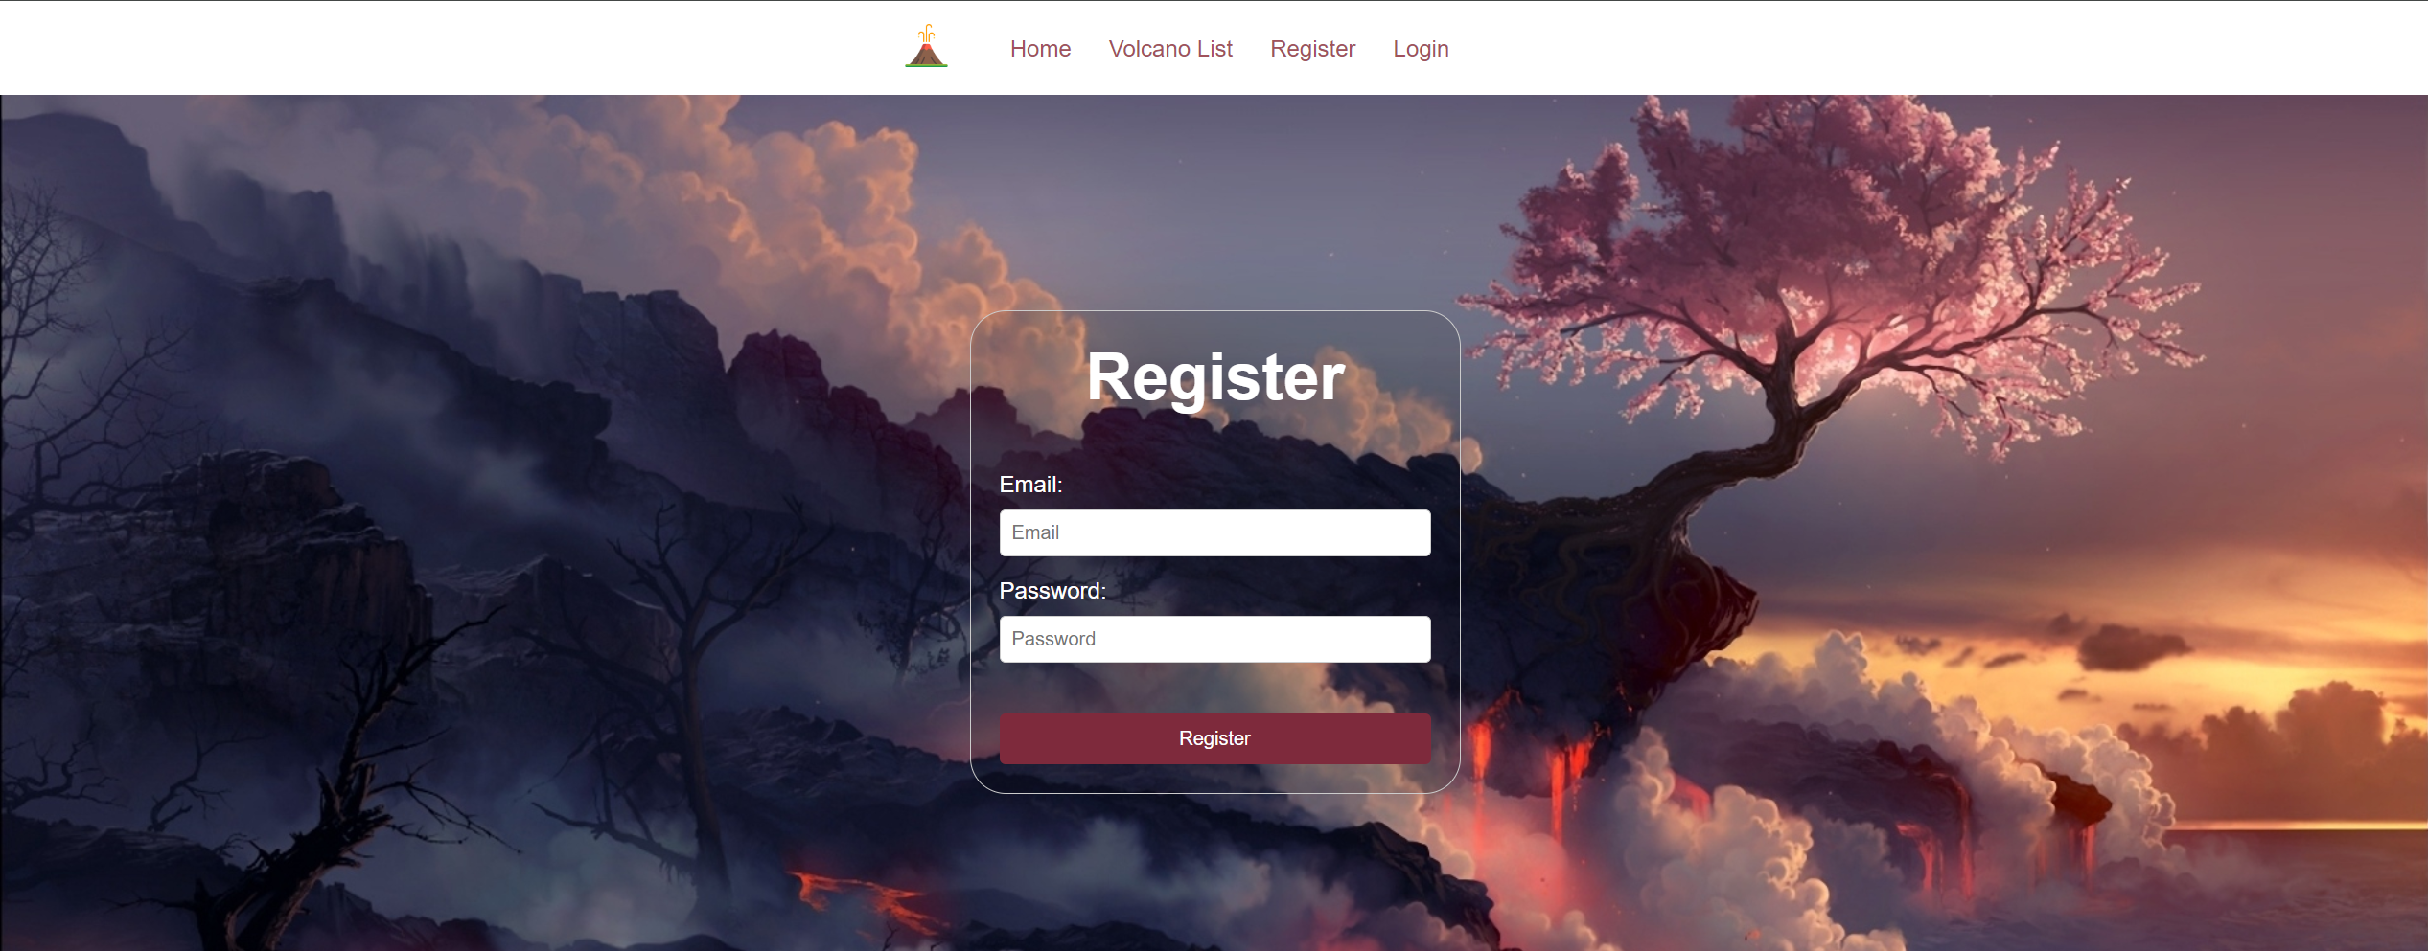

Screenshot5



Screenshot6



Screenshot7

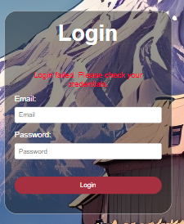

Screenshot8

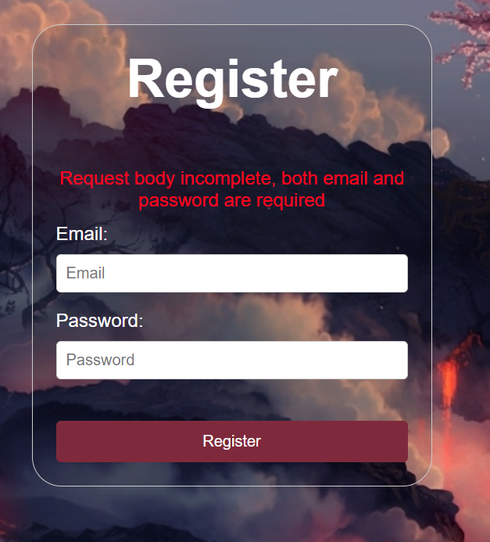

Screenshot9



Screenshot10

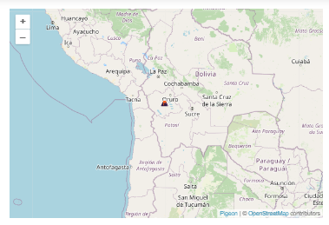

Screenshot11

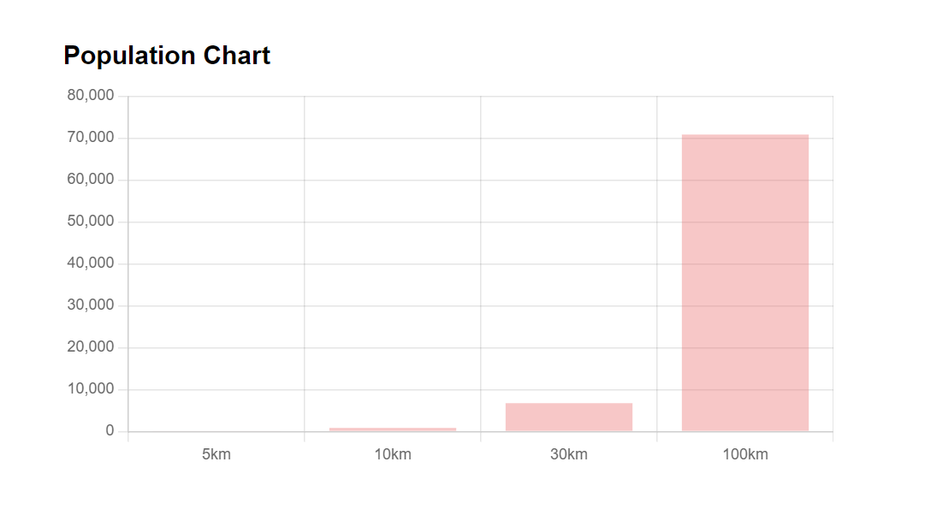

Screenshot12

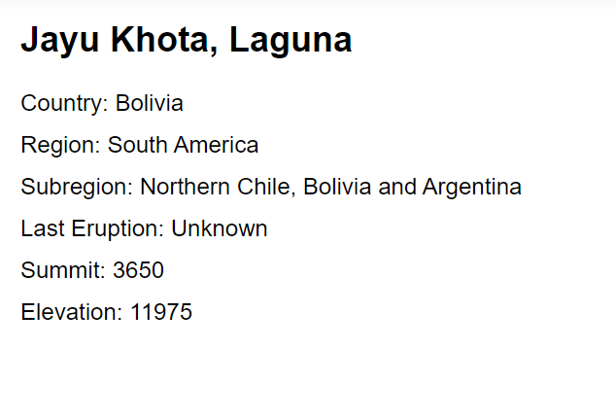

Screenshot14